Netscaler SDX in use with XenServer on a physical device

Netscaler for Web-Applications
- Reverse Proxy between Internet & Webservers
- IP Filtering for external access to Webservers
- Port Filtering for external access (only allow 443 & 80)
- Certificate Management for SSL connections
- Web Application Firewall for Bot Management
- SSL offloading/content switching for public IP addresses (hundreds of URLs behind one public IP address)
- Responder & Rewrite Policies (hundreds of URLs to simplify/shorten URLs for end users)
- SSO/SAML or Kerberos
- Enforces 2FA where in use

Netscaler for Citrix Apps
- 2FA (LDAP & AzureMFA) – Gateway
  - 2FA is enforced for users not on the network
  - SSO for users on the network, no 2FA
- SSO in virtual Apps after Citrix Authentication – Gateway
- Reverse Proxy between Terminal Server & Application Servers

Loadbalancing

Authentication Services
- IDP (SAML)

ORCA Authentication:

- Waveware Fat Client as published app in Citrix
  - Users in VAMED AD
  - SSO into the virtual app with Kerberos & SAML
  - Citrix is accessible from Internet and internally
  - 2FA required for users not on the network to login to Citrix, internally SSO to Citrix
  - access mostly for employees plus some customers with external AD accounts
  - FDT solution - Follow FDT standard for Citrix authentication
- Waveware Webclient (wave webclient):
  - No SSO
  - username & password authentication with local user in waveware (no AD user)
  - Webapp is running on the Waveware application server(s)
  - Access to Webapps over Internet
  - Netscaler is sitting in front of the webclients
  - IP restrictions for most URLs in place (where missing they have to be provided by FHS)
  - 50-100 Users with personalized accounts, external access only
  - FDT solution: stay for now with local accounts, but enforce IP restrictions for all URLs. Find a better solution after migration (e.g. entraID authentication instead of app local users). Temporary exception from security needed.
- Waveware Ticket (netprocess):
  - Webapplication
  - No SSO
  - username & password authentication with local user in waveware (no AD user)
  - Webapp is running on the Waveware application server(s)
  - Access to Webapps over Internet
  - Netscaler is sitting in front of the webclients
  - IP restrictions for most URLs in place (where missing they have to be provided by FHS)
  - 1000+ users, some of them are shared accounts, external access only
  - One WaveWare Instance has “some kind” of connection to a customer (NRZ Rosenhügel) AD to import user data
  - FDT solution: stay as is, enforce IP restrictions for all URLs, improve after migration, possible improvement: establish dedicated WaveWare instance for wave ticket in untrusted landing zone and build a secured interface to “trusted” instances; temporary exception from security needed
- Orca Webapplications (Serviceportal, GMS)
  - These apps are hosted on dedicated application servers
  - Servers are Linux VMs, no domain integration, no VAMED/FHS AD integration
  - No SSO, username & password authentication
  - mainly accessed by customers (hospitals)
  - either unauthenticated access or with customer identities via customer LDAP
  - Customer LDAP, if used, is accessed via Side2Side VPNs
  - Webapps are accessed via Internet
  - Netscaler is sitting in front of the webclient
  - IP restrictions for most URLs in place (where missing they have to be provided by FHS)
  - Some instances maybe at the customer? To be verified?
  - FDT solution: place these application servers in “untrusted” landing zone, no access of internals to these apps required, secure internfaces between trusted and untrusted segement. Publish via azure app gateway with WAF
- FDT solution: stay as is, enforce IP restrictions for all URLs, dedicated “untrusted” landing zone. exception from security needed
- Waveware Mobile App
  - Smartphone App which is managed with Intune
  - Usergroup: internals
  - Microsoft tunnel for Intune is used
  - No SSO, username and password authentication within the App
  - FDT solution: within Fresenius standards, if possible implement SSO
- REST Interfaces
  - WaveWare to WaveWare interfaces for customers
  - Assumption: Side2Side VPNs in use for connection to customer interfaces
  - Username and Password within Application
- SaaS Applications (Ask4Shop, Infobase):
  - Infobase: Login via IdP (Netscaler with FHS AD) initiated user authentication. Infobase is externally hosted (SaaS), infobase manages permissions
  - FDT solution: change IdP from Netscaler to EntraID
  - Ask4Shop: no IdP in use, perdix in use? Discuss with emtec 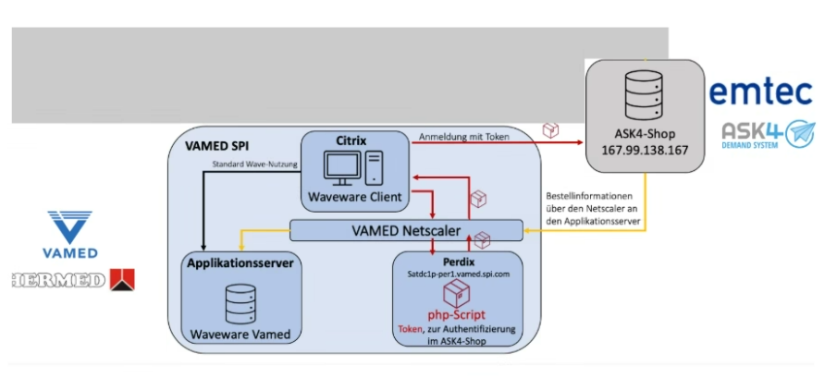

FDT Architecture and security Guidance around Netscaler usage for Orca – Richard Hunt / Rafal Trazska

Netscaler is used within the as is Orca landscape for Authentication and reverse proxy functions.

Netscaler is not an approved technology to use within Fresenius (No architecture or security approval), It is not deployed anywhere in the environment and there is no support available for its usage either from FDT or FDT partners.

To enable Orca migration the recommendation is to move to FDT standard solutions for authentication and Reverse proxy. Specific guidance on the different Orca use cases, target FDT solutions, and where security exceptions should be requested is listed below.

- Citrix Authentication/Reverse proxy:
Source solution:
Netscaler for reverse proxy + authentication (with NPS – MFA extension for external).

Target solution:
Citrix Cloud Gateway service – reverse proxy + authentication (Entra with conditional access MFA- / Citrix FAS) - This is already in place for all FDT citrix services and will apply to any published apps/desktops which are migrated as part of Jerry scope.)

Orca Use Cases:
Waveware Fat Client in Citrix

- SAML Authentication :
Source solution: SAML using Netscaler IDP
Target solution: SAML using FDT Entra as IDP

Orca Use Cases:
Waveware Fat Client in Citrix,
Orca Saas applications (Infobase)

- Apps with built in App, based Authentication:
Source solution: built in application based authentication + Netscaler –Reverse proxy / IP restriction
Target solution: built in application based authentication (Security exception will be required for built in app based auth – requiring alignment with Fresenius Password policy) + Azure App gateway/WAF – Reverse proxy / IP restrictions.

Orca Use cases:
Waveware Webclient
Orca Webapplications (ServicePortal, GMS)
Waveware mobile app
Waveware Ticket (netprocess) - includes use of shared accounts (Security exception will be required for use of shared accounts – improvements should be implemented)

- Apps using Customer LDAP for authentication
Source solution: App configured for LDAP authentication against customer AD, connectivity to customer AD via Barracuda Site to site VPN, Citrix netscaler reverse proxy/IP restrict
Target solution:
    - App configured for LDAP authentication against customer AD, connectivity to customer AD via FDT LAN2LAN service (Site to site VPN using Palo Alto B2B firewall)
    - App servers hosted in separate landing zone from the rest of Orca landscape (due to limited trust - integration to customer)
    - Azure App gateway/WAF – reverse proxy / Waf with IP restrictions.

Orca Use Cases:
Orca Webapplications (ServicePortal, GMS)
Waveware Ticket (one customer – NRZ Rosenhügel setup for customer auth using LDAP)

- Apps with no user authentication required.
Source solution: Reverse Proxy / IP restrictions using Netscaler.
Target solution:
- Reverse proxy / IP restrictions using Azure App Gw/WAF.
- App servers hosted in separate landing zone from rest of Waveware landscape (due to limited trust – no authentication)
Clarification required to understand the type of data stored and to create plan for enforcing user based authentication for all users (e.g. local users, shared accounts, or mandatory customer AD integration)

Orca Use Cases:
Orca Webapplications (ServicePortal, GMS) - (use case with no user auth apart from ip restriction)

- Mobile apps connectivity
Source solution:
Mobile client private network connectivity using Vienna Intune VPN (Clients MDM managed by FHS Intune)
Mobile URL published via Netscaler
Target solution:
Mobile client private network connectivity using FDT Microsoft Tunnel for Intune connector (VPN client – MS defender for intune)
(Clients MDM managed by FDT Intune)
Mobile URL published via Azure APP GW

Orca Use Cases:
Waveware Mobile app

- Interfaces Connectivity and authentication

Source solution:
Connectivity to customer via Barracuda Site to site VPN
Authentication using Service account (username/password )
Target solution:
Connectivity to customer via FDT LAN2LAN service (Site to site VPN using Palo Alto B2B firewall)
Authentication using : Service account is acceptable , must ensure communication is using https and through tunnel connection : (Security Recommendation to improve security – check feasibility to change to Bearer/ OAUth2 option).

Orca Use Cases:
Rest Interfaces

- Reverse Proxy/WAF for external and internal : (IP filtering, port filtering, Web app firewall, respond/rewrite policy, TLS termination/cert management e.t.c.)
Source solution: Netscaler
Target solution: Azure App Gateway with WAF.

Orca Use Cases:
Citrix / Waveware Fat client
Waveware Webclient
Waveware Ticket
Orca Webapplications (Serviceportal, GMS)
Waveware mobile app

